Supporting Information for:

Easy-to-use analysis tool for untargeted full MS/AIF experiments including CID fragment annotation.

Table of Contents
2 Using the tool 1
3 Working with the results 3

Using the tool
For the sake of this analysis, the tool was hosted on a personal computer, however, it may also be hosted on a server to allow all group members to access the tool without additional administration. All interaction with the tool is done via a custom website. Evaluation of the measurement results of the standard mixture was started by uploading the *.mzML file of the MS measurement (along with optional metadata) via a page hosted on the server. The analysis itself is then started by selecting the uploaded file and uploading a peak list of the individual m/z and their corresponding retention times into an input mask of the tool. After clicking a button, the analysis has started. After the analysis has been completed, the individual results can be downloaded through the website.
After initial installation of the tool, settings should be set once according to the specific instrument and instrument method that is used. This can easily be done by accessing the corresponding website, changing the values and saving the new values.

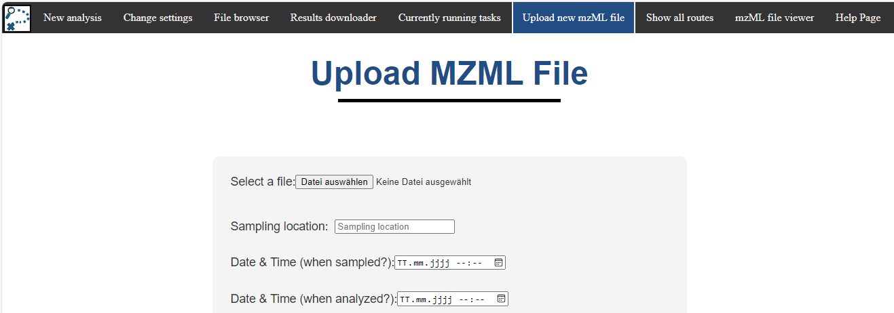
Figure 2: Step 1: Uploading the .mzML file to the server.
The website contains a navigation bar (top horizontal bar (black)), which allows easy navigation through the website. Optional metadata (like sampling location, ….) can be given during upload of the *.mzML file.
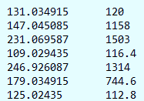
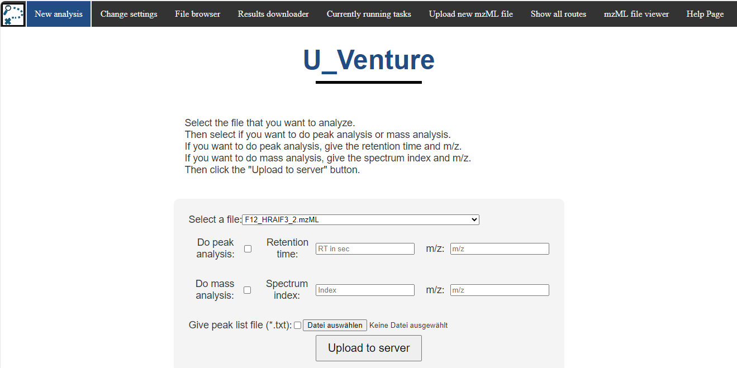
3.)
2.)
1.)
Figure 3: Step 2: Starting a new analysis via a given peak list.
“New analysis” in the navbar directs to this site. Here the user may select a previously uploaded *.mzML file and select the type of analysis that should be conducted. “Peak analysis” will conduct an analysis of the molecular ion and its fragments. “Mass analysis” will only predict the formula of the given m/z in the given spectrum. If a peak list is given, the tool does a “Peak analysis” of each given peak.
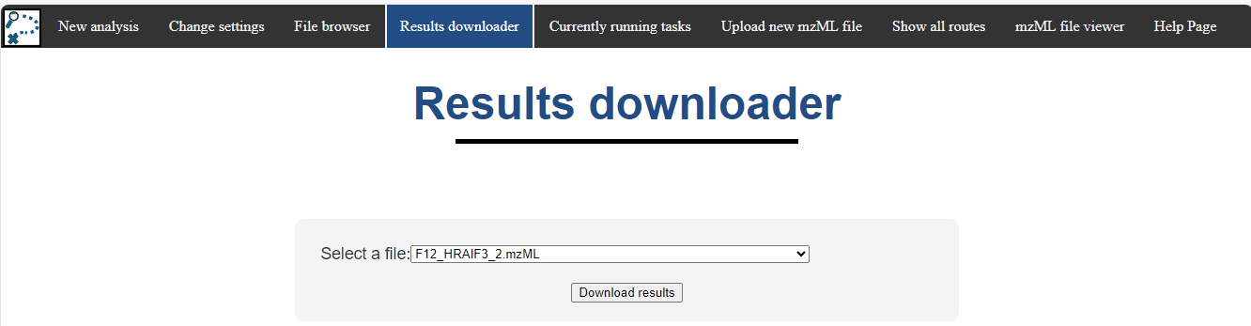
Figure 4: Step 3: Downloading finished results in a .zip file.
If the analysis is finished, the results can be downloaded in a *.zip file. The file contains all results that were computed for the corresponding measurement.
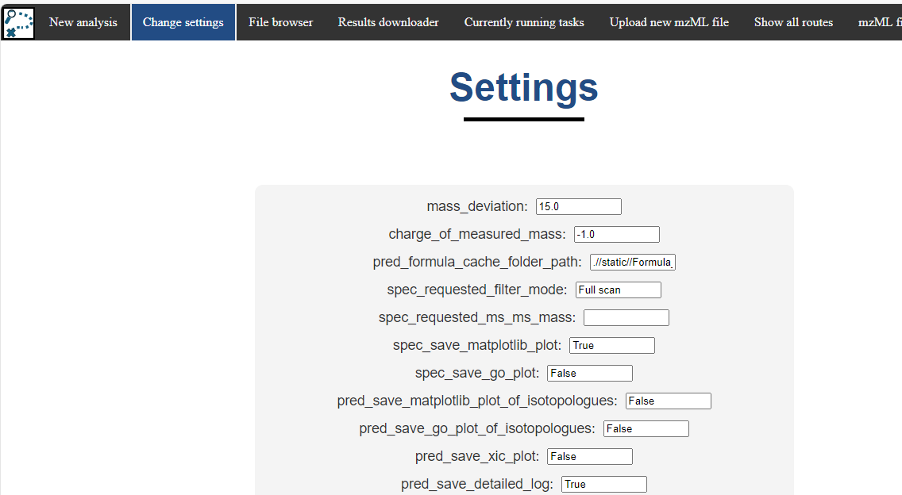
Figure 5: Settings page.
Settings that control formula prediction may be changed from a webpage within the tool. A variety of values provide customizability to allow the tool to be used with multiple different LC/MS systems. Once the

Individual Results
Table 3: Summary of the results of the standard mixture. The shaded area in the “compound” column indicates weather the formula was correctly predicted. The shaded area in the “fragments match” column indicate whether the fragments were correctly identified, and their corresponding formula correctly predicted. The first number in that column shows the number of fragments that were found by the tool, whereas the second number shows the number of fragments that were found by evaluating the MS² measurements manually.
Compound  CID energy: (a) = 11,25,35 (b)=11,30,90 | True formula | Predicted formula | Fragments match | Log (I)
(a) Ibuprofen | C₁₃H₁₈O₂ | C₁₃H₁₇O₂ | 0/0 | 6.3
(a) 3-Maleimidopropionic acid | C₇H₇NO₄ | C₇H₆NO₄ | 0/1 | 6.4
(a) Maleic Acid | C₄H₄O₄ | C₄H₃O₄ | 1/1 | 8.5
(a) 2-Methylsuccinic acid | C₅H₈O₄ | C₅H₇O₄ | 1/1 | 8.3
(a) 4-Nitro-1-naphthol | C₁₀H₇NO₃ | C₁₀H₆NO₃ | 1/1 | 9.5
(a) 2-Nitrobenzoic acid | C₇H₅NO₄ | C₇H₄NO₄ | 0/0 | 7.5
(a) 2-Nitrophenol | C₆H₅NO₃ | C₆H₄NO₃ | 0/1 | 6.9
(a) 4-Methyl-2-nitrophenol | C₇H₇NO₃ | C₇H₆NO₃ | 2/2 | 9.1
(a) p-Nitrophenylhydrazin | C₆H₇N₃O₂ | C₆H₁₀SF₂ | xxx | 6.4
(a) 3-Nitrosalicylic acid | C₇H₅NO₅ | C₇H₄NO₅ | 2/1 | 9.0
(a) 2,6-Dimethyl-4-nitrophenol | C₈H₉NO₃ | C₈H₈NO₃ | 2/2 | 9.2
(a) 4-Nitrocatechol | C₆H₅NO₄ | C₆H₄NO₄ | 0/2 | 6.7
(a) Salicylic acid | C₇H₆O₃ | C₇H₅O₃ | 1/1 | 8.4
(a) 2-Sulfobenzoic acid | C₇H₆O₅S | C₇H₅O₅S | 1/0 | 7.5
(a) Syringic acid | C₉H₁₀O₅ | C₉H₉O₅ | 0/0 | 6.1
(a) Syringaldehyde | C₉H₁₀O₄ | C₉H₉O₄ | 1/5 | 6.8
(a) Vanillin | C₈H₈O₃ | C₈H₇O₃ | 1/2 | 7.6
(a) N-Phenylmaleimide | C₁₀H₇NO₂ | C₇H₇NO₃F | xxx | 5.9
(a) Nitrobenzene | C₆H₅NO₂ | C₆H₄NO₂ | 0/0 | 7.0
(b) Acetylsalicylic acid | C₉H₈O₄ | C₉H₇O₄ | 2/2 | 6.2
(b) Benzene-1,3,5-triol | C₆H₆O₃ | C₆H₅O₃ | 1/4 | 7.0
(b) 4-Acetamidophenol | C₈H₉NO₂ | C₈H₈NO₂ | 1/5 | 7.3
(b) Pimelic acid | C₇H₁₂O₄ | C₇H₁₁O₄ | 5/3 | 8.1
(b) Benzoeic acid | C₇H₆O₂ | C₇H₅O₂ | 0/0 | 7.4
(b) 3´,5´-Dimethoxy-4´-hydroxyacetophenone | C₁₀H₁₂O₄ | C₁₀H₁₁O₄ | 0/NA | 6.1
(b) 2-Carboxybenzaldehyde | C₈H₆O₃ | C₈H₅O₃ | 3/2 | 8.5
(b) Camphor-10-sulfonic acid | C₁₀H₁₆O₄S | C₁₀H₁₅O₄S | 0/1 | 8.3
(b) trans-Cinnamic acid | C₉H₈O₂ | n.a. | xxx | 6.1
(b) Glutaric acid | C₅H₈O₄ | C₅H₇O₄ | 3/2 | 8.4
(b) 2-Iodbenzoic acid | C₇H₅IO₂ | C₇H₄IO₂ | 0/1 | 7.8

Working with the results
As stated above, the results for 2,6-Dimethyl-4-nitrophenole (molecular weight (ion): 166.0509 g/mol; retention time: 22.3 min; XIC see Figure 5) will be evaluated as an example. Note that for every other peak that was given to the tool, an equal evaluation has been made automatically. During the whole evaluation process, logfiles are created, which might help in the case of uncertainties about the formula prediction or fragment annotation. Those logs also help if unforeseen errors occur.
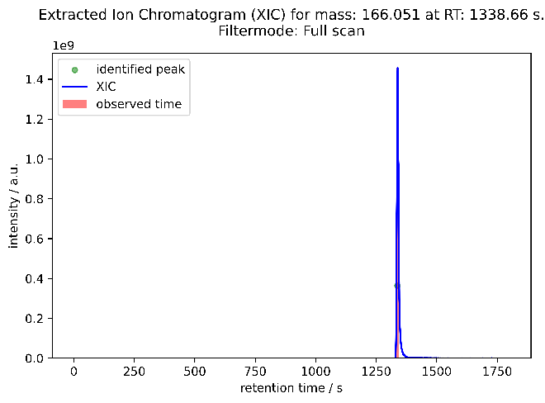  Figure 6: Extracted ion chromatogram for mass 166.0510 u. A peak at 1339 s can be identified in the full MS spectra of the LC/MS run. | 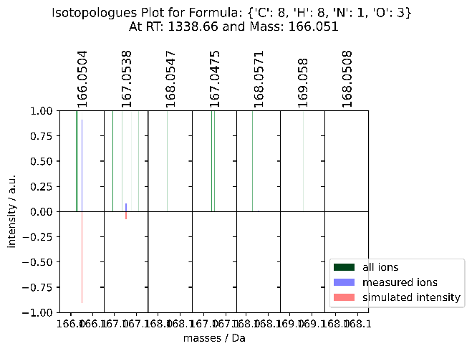  Figure 7: Plot of the measured isotopologues and the simulated isotopologues for the molecular formula C₈H₈NO₃.

Upon starting the analysis, the tool firstly predicts the sum formula for the molecular ion, and for the most likely molecular formula, an isotopologue matching plot is created (see Figure 6). After successful prediction, the tool automatically searches for likely fragments. To evaluate what masses might be fragments of the given molecular ion, the normalized extraction ion chromatogram (XIC) of the molecular ion and the XIC of the potential fragment mass are overlayed and the area between the curves is calculated. This area is a measure for the similarity of the two XICs (other similarity measures like cosine similarity, … have also been tested, however the area between the curves proofed to be best). Figure 7 shows the resulting plots of this evaluation. Subfigures a) and b) indicate a good matching of the peak shapes of the molecular ion (mass 166.0509 g/mol and 135.0451 g/mol and 107.0503 g/mol). Those masses are therefore likely to be fragments of the molecular ion. Subfigure c) contains the normalized extracted ion chromatogram of mass 118.9243 g/mol. The peak shape of this mass and the molecular ion do not show a good matching, indicating that this mass is not likely to be a fragment of the molecular ion. The tool then automatically decides, if a mass is a fragment of the molecular ion, or if a mass is not related to the molecular ion. If a fragment is detected, it continues to predict the molecular formula of the fragment mass.
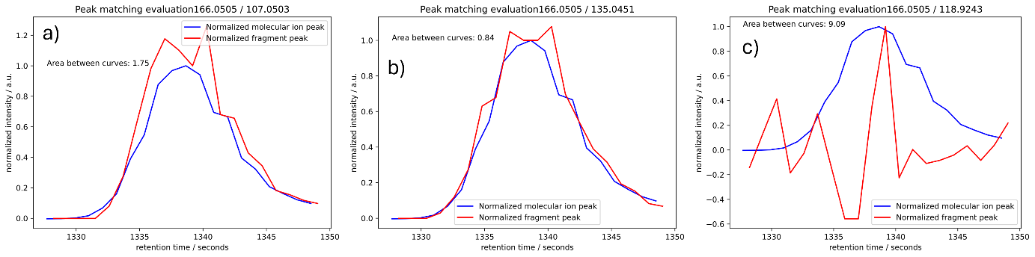
Figure 8: Plots of the peak similarity for selected masses. Subfigure a) and b) show good matching fragment masses, where subfigure c) shows a non-matching mass.

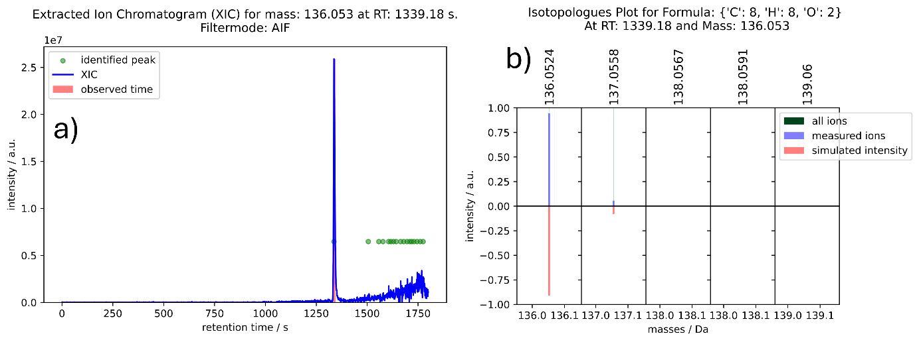
Figure 9: a) XIC of mass 136.0530. Shown are only the values of the AIF spectra. b) Isotopologue matching plot for formula C₈H₈O₂.

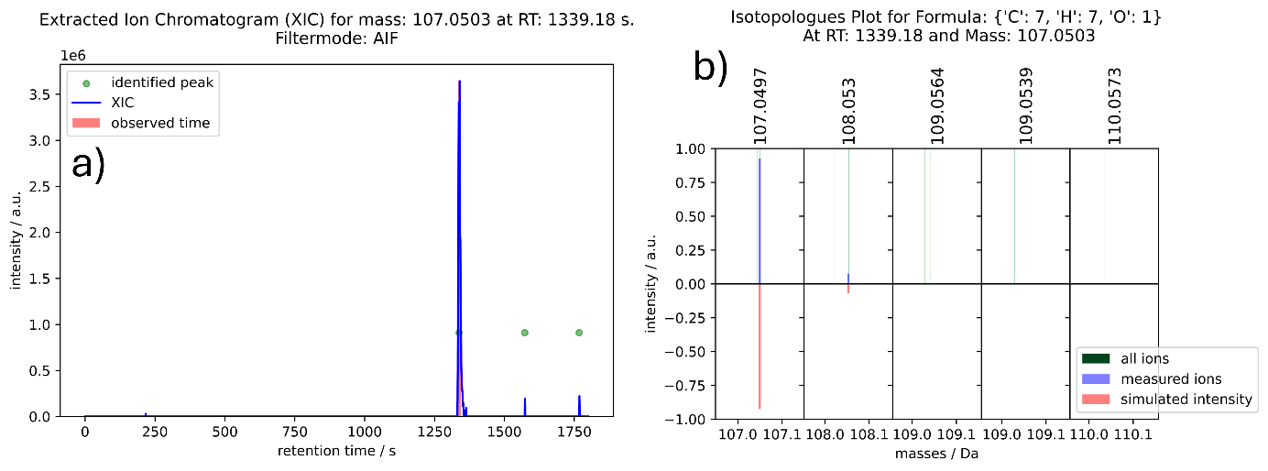
Figure 10: a) XIC of mass 107.0503. Shown are only the values of the AIF spectra. b) Isotopologue matching plot for formula C₇H₇O₁.

For every fragment prediction that is made by the tool, a plot of the extracted ion chromatogram of the specific mass-to-charge ratio is created. If a molecular formula is found, a plot of the measured and the simulated isotopologue intensities is created. When in doubt, this plot helps in evaluating if the predicted molecular formula has a realistic isotopologue pattern.
In the end, a summary plot is created (see Figure 10). This figure shows the AIF spectrum with highlighted masses of the molecular ion and the identified fragments. This graph should resemble the results of an isolated MS² experiment. Additionally, the XIC of the mass is given. This helps in evaluating the polarity of the molecular ion that was evaluated.
In summary, for the molecular ion with mass 166.0505 g/mol and retention time 1338.6 s, the tool identified the correct sum formula C₈H₈NO₃, and identified the fragments with 136.0530 g/mol C₈H₈O₂, and 107.0503 g/mol C₇H₇O₁. As can be seen in Figure 12 those fragments were also found in a MS² experiment that was manually evaluated. The MS² experiment revealed that an additional fragment with mass-to-charge ratio 135.0451 was created during fragmentation. However, it was not found by the tool, as the isotopologue peak was shadowed by the more intense fragment peak with mass-to-charge ratio 136.0529. The peak with mass 123.0454 proofed to be noise, as no peak could be observed in the extracted ion chromatogram for this mass. This shows that this mass (although measured in the MS² experiment) is not related to the molecular ion with mass 166.0505. The intensities of the fragment ions during the MS² experiment are comparable to the intensities measured during the AIF scan.

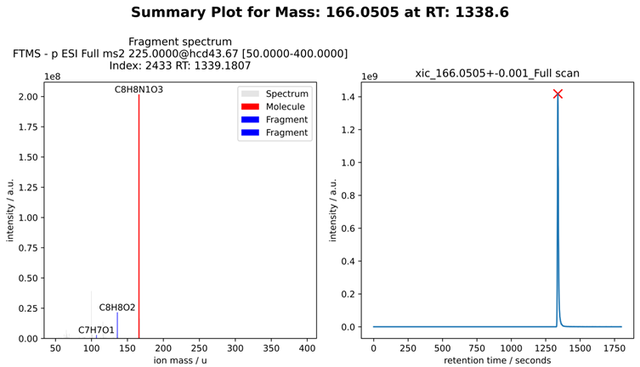
Figure 11: a) Mass spectrum (AIF) with the molecular ion and its fragments marked. The plot should resemble the mass spectrum as would be obtained if an isolated MS2 experiment would be conducted. b) XIC of the analyzed mass.

Figure 12: Mass spectrum of a multiplexed MS² experiment. Mass 166.0510 and 59.0139 were fragmented in the CID cell. Fragmentation energies were the same as for the AIF experiments. This experiment was used to validate the results obtained with the tool.

Pseudo code / analysis workflow
Workflow (end user)
- Access the website via a normal browser.
- Upload .mzML file of the MS data.
- Submit new analysis of mass (m/z) at retention time (rt). Or upload a peak list (list of multiple m/z and rt) for batched analysis.
- Wait for the tool to finish analysis.
- Download results
Workflow (administrator; setting up the tool)
- Adjust firewall / networking rules to allow access from within the local network.
- Add a data storage to the server. (Depending on the needs of the working group).
- Download repository and install the dependencies of the tool (python + libraries).
- Start the webserver.py file.
- With one for the working group typical MS file, change initial/default settings to optimize performance of the predictions. Adjust the settings of the tool to the characteristics of the instruments that are used in the working group (e.g. resolution of the MS, noise floor, range of intensity fluctuations, …).
- While the server is running: regular backups.
Tool workflow (hidden from the user; executed in the background) (formula prediction and fragment annotation)
- Preparing spectra of interest full MS & AIF.
- Summarizing measured masses according to MS resolution.
- Calculating possible formula candidates based on the exact mass of the molecular ion.
- Rating isotope matching of the formula candidates (molecular ion).
- Repeat step 3 + 4 for the neighboring full MS spectra -> improves S/N ratio and increases overall reliability of the prediction.
- Select possible fragment ions in the AIF spectrum (all fragments need a mass lower than the mass of the molecular ion).
- Compare peak shape similarities between molecular ion and the potential fragment mass.
- Calculate formula of the fragment ions.
- Calculate possible neutral loss formulas based on exact mass of the neutral loss.
- Test if fragment formula + neutral loss yields the formula of the molecular ion. If positive, append the fragment to the true fragment list.
- Create isotopologue matching plots, mass spectra plots with true fragment masses highlighted, extracted ion chromatogram plots, logfiles and a summary textfile.

